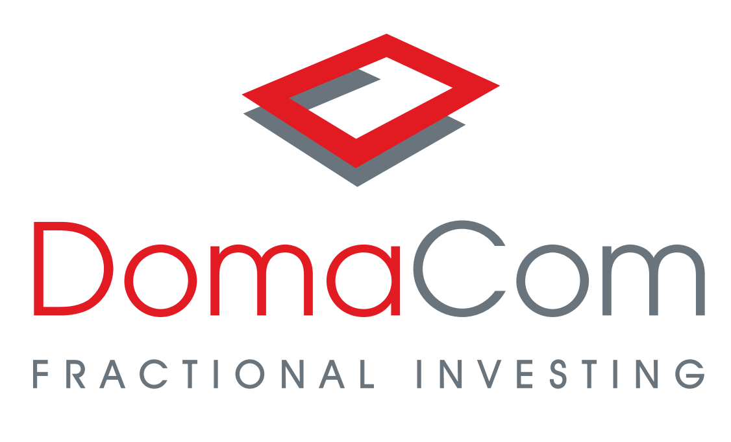

ESG investing comes of age

A decade or two ago, ethical investing was akin to a cottage industry: a lofty notion but appealing only to socially conscious, inner-city dwellers. How times have changed.
Today, so-called environmental, social and governance (ESG) considerations are central to the investment mandates of most major global fund managers – and a key discussion point around company board rooms.
Offshore, responsible investing has developed a powerful head of steam, with investment giants like Blackrock and AXA Investment Management reporting strong flows into their responsible investment products.
No matter the definition one prefers to use, ethical or ESG issues are fundamentally changing the investment landscape.
In the past, ethical investing has been more about a passive stance of avoiding the ‘usual suspects’ of tobacco, alcohol and gambling companies, weapons purveyors and overtly environmentally destructive practices such as rainforest clearing.
While so-called negative screening of undesirable practices remains important, the emphasis has turned to active, or ‘impact’, ESG investing. This means actively supporting enterprises that are working on ethical solutions to societies most pressing issues.
In respect to carbon abatement, that means investing in wind, solar, large-scale battery, bio and hydrogen projects.
Other examples are recyclers or companies that treat plastic waste otherwise destined for landfill or swirling and washing around our oceans and waterways.
The ‘social’ element of ESG covers aspects such as non-discriminatory hiring practices, affirmative action and avoiding products or services derived from slave labour.
The ‘governance’ part relates to how listed companies conduct themselves on issues such as executive pay and board diversity.
During the pandemic, investors and their advisers might have reverted to the conservative mindset of investing only in what they know.
In reality, they have moved towards to ESG investments even though the scope of the sector is open to interpretation.
Research house Morningstar describes the “blistering pace” of the growth of the sustainable Australian managed funds sector. At June 30 2021, “retail assets invested in Australasian sustainable investments” stood at $33.4 billion, 66 per cent higher than a year ago. The sector also recorded record funds flow of $2.9 billion in the June quarter. Tellingly, 66 per cent of the inflows are directed at active ESG mandates, as opposed to simply avoiding harmful practices.
In its 2020 benchmark survey, the Responsible Investment Association Australasia (RIAA) reports that 44 Australian fund managers with $1,149 billion of assets met at least 75 per cent of responsible investing guidelines. These ethically-inclined fund represented 37 per cent of $3,135 billion of total assets under management.
“The penny has dropped that you can’t invest in a company that is not handling climate risk or abusing its social licence to operate,’’ says RIAA chief executive Simon O’Connor.
Increasingly, the ‘E’ in ESG is being highlighted given the imperative to reduce global warming to acceptable levels.
The issue has only gained urgency after the United Nations’ Intergovernmental Panel on Climate Change in August affirmed the need to halve emissions in the next decade, to stay within 1.5 degrees Celsius and reach the global target of net zero emissions by 2050.
The report claims current investment in low-carbon technologies would need to increase five-fold even to contain global warming to the higher limit of two degrees.

With $US135 billion under management, the London based active funds manager Man Group typifies how seriously the big end of town is treating the issue.

“The UN’s latest report …. represents an existential risk, including how we run our businesses, how asset managers will manage clients’ money and how we can contribute to society,” Man Group’s chief operating officer and head of ESG Robyn Grew says.

“It’s incumbent upon the financial services industry to assume greater responsibility and act as powerful drivers for much-needed climate action. We must evaluate climate risk, engage with companies, vote for climate action and continue to decarbonise our portfolios.”

In the meantime, professional investors are also taking an increasingly dark view of companies taking ESG shortcuts – and are using forums such as the current annual meeting season to voice their views.
Conventional wisdom was that taking an ethical stance meant sacrificing returns, with the so-called ‘sin’ stocks generating superior returns.
The good news is that along the green-tinged ESG journey, investors don’t need to be out of pocket to have a clear conscience.
According to the RIAA benchmark report, ethical Australian share funds achieved an average one-year return of 24.7 per cent, pipping the overall sector average of 22.3 per cent. Ethical five-year returns averaged 10.1 per cent, compared with 7.8 per cent for the standard funds.
As the ESG landscape evolves, more emphasis is being placed on so-called impact investing, which means a positive focus on sustainable and socially responsible enterprises.
Think of it as being a more intense manifestation of the active ESG investing ethos. Far from being an act of altruism, impact investing is all about generating a measurable social or environmental benefit as well as a respectable financial return.
A more direct route to investing in ESG
On a small scale DomaCom’s fractional investment platform allows retail investors and their advisers access to transformative ‘impact’ developments at an affordable price.
These include renewable energy projects delivering an income return, NDIS (National Disability Insurance Scheme) delivering a strong government supported income stream, affordable housing for essential workers with a combination of income and capital growth, and rural farmland that offers rental income and capital growth.
The home equity release market, re-energised by the government retirement income review, offers fractional investment to retail investors for the first time via the DomaCom product.
This market has only ever been serviced by institutional funders lending on homes via a credit regime. Now investors can “own” a percentage of established residential property, including that of family members and friends.
An equity mortgage fund is being added to the growing list of options for investors and advisers who can now put their money into the acquisition and development of projects for the type of returns normally reserved for institutions, who use investors money for the same things but keep the lion’s share of the returns.
The benefit to investors is not just in the returns or the feeling that their investment is helping people and communities but also in its diversification aspect, the number one risk mitigation strategy for retail investors. This applies equally to individuals and SMSFs.
DomaCom’s fractional model, particularly with financial advisers involved, also lends to liquidity with an online secondary market where investors can trade their units with other investors. The advisers role is in facilitating or introducing investors.
The fractional model introduced to the market by DomaCom as a financial product has turned property investing on its head allowing individuals and advisers to create syndicates on the fly for assets they are interested in and with like minded people.
To learn more visit www.domacom.com.au

www.domacom.com.au

This article provides general information only and has been prepared without taking into account the objectives, financial situation or needs of individuals. The information contained in this article reflects, as of the date of publication, the views of DomaCom Australia Limited ABN: 33 153 951 770, AFSL 444365 (DomaCom) and sources believed by DomaCom to be reliable. We do not represent that this information is accurate and complete, and it should not be relied upon as such. Any opinions expressed in this material reflect our judgment at this date, are subject to change and should not be relied upon as the basis of your investment decisions. All reasonable care has been taken in producing the information set out in this article however subsequent changes in circumstances may occur at any time and may impact on the accuracy of the information. Neither DomaCom, its related bodies nor associates gives any warranty nor makes any representation nor accepts responsibility for the accuracy or completeness of the information contained in this article. Past performance is not a reliable indicator of future performance. Investing involves risk including loss of capital invested. ©2021 DomaCom Australia Limited.

